**TATA Cars in Mumbai on cars24.com**

Analysis and Insights

1. Distribution of Cars by Fuel Type:

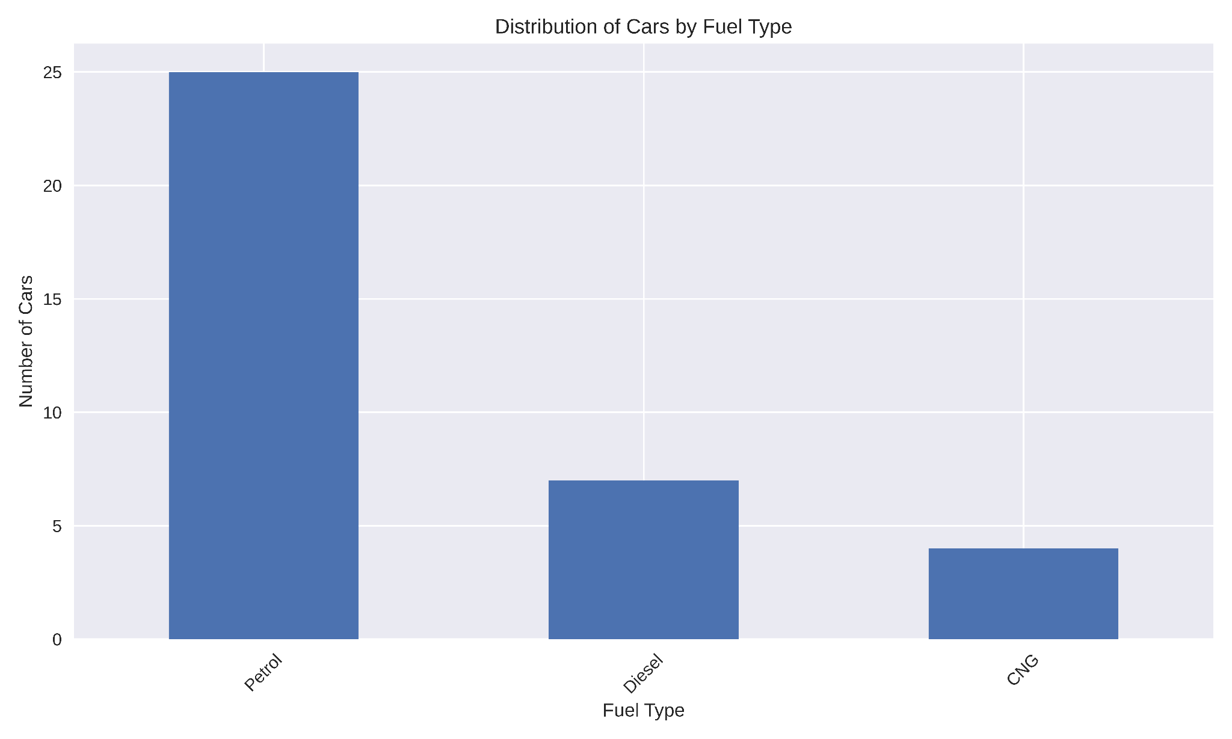

Petrol cars dominate the dataset, with 25 cars compared to 7 diesel cars and 4 CNG cars.The bar chart provides a clear visual comparison of the distribution of cars by fuel type, showing the predominance of petrol cars.

1. Price vs Kilometers Driven by Fuel Type:

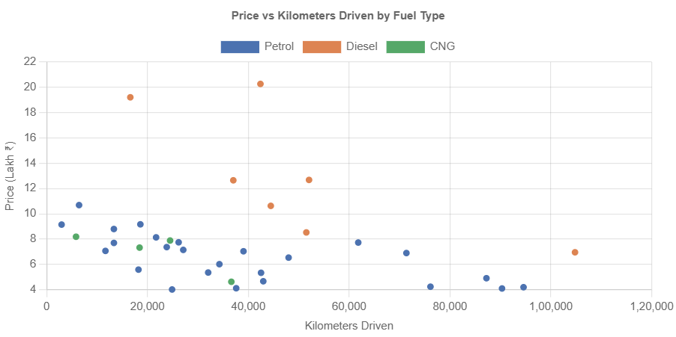

This scatter plot illustrates the relationship between the price of cars and the kilometers driven, with different colors representing fuel types. We can observe that there's a general trend of lower prices for cars with higher mileage, which is expected. The plot also shows that diesel cars tend to be priced higher than petrol cars, especially for lower mileage vehicles.

1. Average Price by Transmission Type:

|  | Price |
| --- | --- |
| Transmission |  |
| Automatic | 8.65857142857143 |
| Manual | 7.341818181818183 |

This data shows that automatic transmission cars have a higher average price (8.66 Lakh ₹) compared to manual transmission cars (7.34 Lakh ₹). This suggests that automatic transmission is considered a premium feature in the Tata cars market in Mumbai.

4. Correlation between Year and Price:

Correlation between Year and Price: 0.51

The correlation coefficient of 0.51 indicates a moderate positive correlation between the manufacturing year and the price of the car. This suggests that newer models tend to be more expensive, which is a common trend in the automotive market.

5. Average Prices of Tata Car Models by Year of Manufacture:

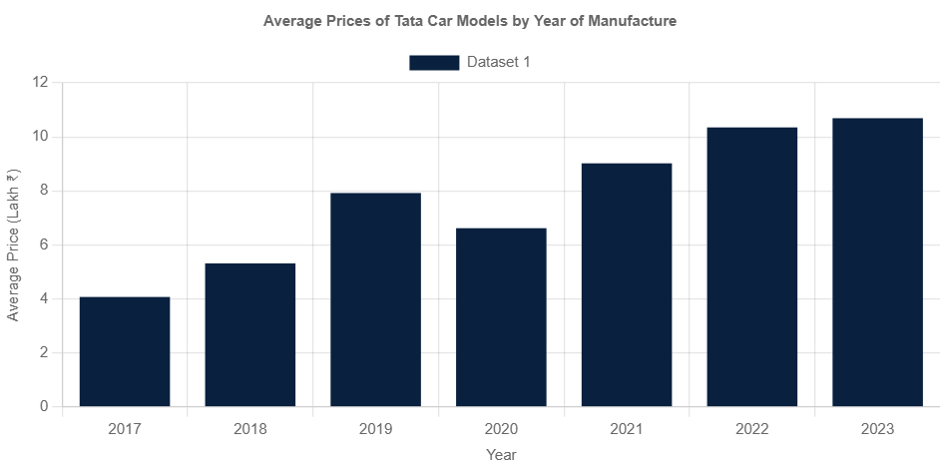

This graph visually represents the average prices of Tata cars for each year from 2017 to 2023. We can see a general upward trend in prices over the years.

| **year** | **Price** |
| --- | --- |
| **2017** | 4.07 |
| **2018** | 5.3133333333333335 |
| **2019** | 7.918571428571428 |
| **2020** | 6.616666666666667 |
| **2021** | 9.018333333333333 |
| **2022** | 10.348749999999999 |
| **2023** | 10.69 |

As we can see:

- 2017 models have the lowest average price at 4.07 Lakh ₹

- There's a significant jump in average price for 2019 models (7.92 Lakh ₹)

- The most recent years (2021-2023) show the highest average prices, with 2023 models averaging 10.69 Lakh ₹

It's important to note that these averages might be influenced by the specific models available for each year and the number of cars in the dataset for each year.

Overall Price Statistics:

|  | **Price** |
| --- | --- |
| **count** | 36.0 |
| **mean** | 7.853888888888889 |
| **std** | 3.684949526909835 |
| **min** | 4.02 |
| **25%** | 5.355 |
| **50%** | 7.24 |
| **75%** | 8.5975 |
| **max** | 20.27 |

These statistics give us a broader view of the price range:

- The average price across all years is about 7.85 Lakh ₹

- The cheapest car in the dataset is priced at 4.02 Lakh ₹

- The most expensive car is priced at 20.27 Lakh ₹ - 50% of the cars (median) are priced at 7.24 Lakh ₹ or below

This analysis provides a comprehensive view of how Tata car prices vary by year of manufacture in the Mumbai market, based on the data provided